Beckett Hall Fire Pit
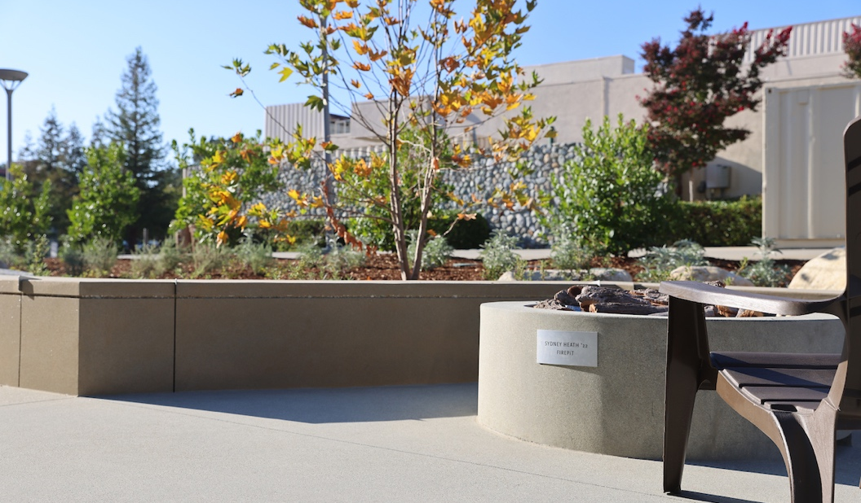

The fire pit is a substance free place for people to hang out, talk, laugh, and make memories.
Please ensure a safe and enjoyable experience for all by adhering to the following guidelines.

In case of emergency, call Campus Safety 909-607-2000

Instructions
- The fire pit is available on a first-come, first-served basis, and must be attended constantly by a responsible CMC student when in use. Please limit usage to 90-minutes if there are other groups who would also like to enjoy the space.
- The fire pit must be turned off and the patio area cleared of all people by midnight, Sunday-Thursday and by 1 AM, Friday-Saturday.
- The fire pit is controlled by a timer switch, located on the exterior north wall of Beckett Hall and a remote control. Prior to switching on the fire, the users must:
  - Conduct a visual inspection of the pit and the surrounding area to make sure there is no debris, flammable objects, water in the pit, or other hazards that could present a safety risk. All hazards must be removed prior to turning on the fire pit. Contact Campus Safety if there is a hazard you are not able to mitigate.
  - Confirm there is no visible damage to the fire pit. If there is damage of any kind, do not use the fire pit. Place a FACS work order describing the issue.
  - Locate the yellow, emergency shut off button, to the left of the timer switch. Pressing that button will immediately shut off the fuel source and extinguish the flame. Public Safety officers have to reset the system after an emergency shut off.
  - To start the fire, turn the timer past 2 and then, using the remote, click the “O” button while pointing the remote to the small opening at the bottom of the pit. It may take up to 30 seconds for the system to purge the air and ignite.
  - You can also ignite the fire pit using the HPC Fire App on your phone.
  - The flame intensity can be “high” or “low” and is adjusted with the up and down arrows on the remote, respectively.
- If you smell gas, shut off the fire pit immediately using the yellow, emergency shut off button.
- After using the fire pit, please turn the timer switch to the off-position, and confirm that all flames are extinguished.
- Make sure that all trash is properly disposed and that the fire pit area is left clean and organized for the next users. Failure to clean and maintain the fire pit is inconsiderate, dangerous, and reduces the lifespan of the common area.

Prohibited Activities

- Alcohol and other substances are not permitted at the fire pit or in close proximity. Similarly, persons using the fire pit cannot be under the influence of alcohol or other substances, including smoking or vaping.

- No fuel or flammable objects can be added to the fire pit. This includes leaves, sticks, wood, charcoal, paper, etc.

- Loud music cannot be played at the fire pit. The proximity to residential rooms requires that music and other noise levels remain at a moderate level at all times.

- The fire pit may not be used during precipitation events (rain, sleet, heavy mist), high winds, high fire danger conditions, or when prohibited by any college official, including but not limited to the Dean of Students Office, Public Safety, TCCS Campus Safety, the LA County Fire Service, or law enforcement officials.

- Use of the fire pit for cooking is prohibited, with the exception of roasting marshmallows. (roasting skewers can be checked out at DOS).

- Fire pit users may not leave litter or any mess at the fire pit area.

- Any behavior that violates these policies or otherwise puts the health and safety of any member of the community at risk will be addressed through the student conduct process and, if warranted, by local authorities. The privilege to use the fire pit can be revoked at any time.

